‘Assault’ on residential school students' identities began the moment they stepped inside
Douglas Quan June 2, 2015

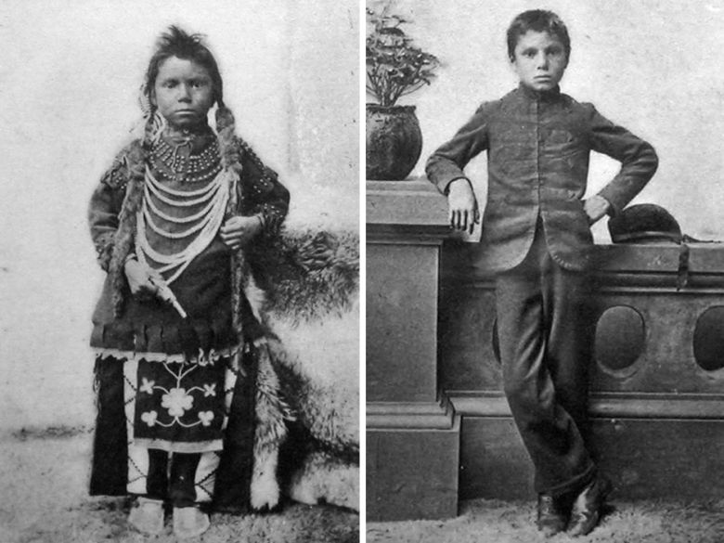
Their aboriginal names were replaced with Euro-Canadian ones. Worse, teachers would often refer to students only by their numbers, according to the TRC summary report
Library and Archives Canada, 1897
The moment indigenous children stepped foot in residential schools, the “assault” on their identities began — and included having their aboriginal names replaced with Euro-Canadian ones.
Worse still, each student was assigned a number and teachers would often refer to students only by their numbers, according to a summary report released by the Truth and Reconciliation Commission.
The commission called on all levels of government Tuesday to allow survivors of the church-run residential school system to “reclaim” their original names and waive for a period of five years any administrative costs related to having their names revised on driver’s licences, health cards, passports and other identity documents.
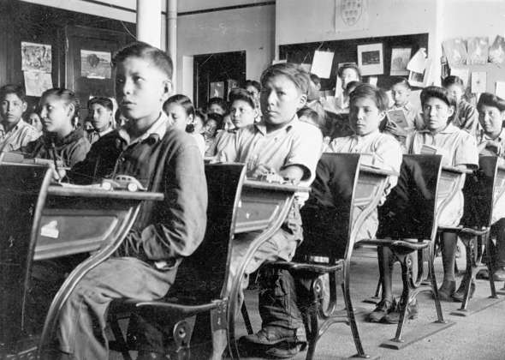
“It seems straightforward to me. That’s a small amount of money to right a past wrong,” said Ry Moran, director of the University of Manitoba’s National Centre for Truth and Reconciliation, which will house all the records amassed by the commission. It was not clear from the report how many residential school survivors would wish to have their names changed. A spokeswoman for Citizenship and Immigration Canada said the government was reviewing the recommendations.
In its report, the commission described how the practice of wiping away students’ aboriginal identities began “the moment the child took the first step across the school’s threshold.”
Braided hair, which often had spiritual significance, was cut; homemade traditional clothing was replaced with school uniforms; and aboriginal names were replaced with Euro-Canadian names.
At the Aklavik Anglican school in the Northwest Territories, an Inuit girl named Masak was re-named Alice. At the Qu’Appelle school in Saskatchewan, a boy named Ochankugahe was renamed Daniel Kennedy after the biblical Daniel.
Truth and Reconciliation Commission Peter Nakogee told the commission that when he attended a residential school in Fort Albany, Ont., he spoke no English. When he was told to write down his name, he angered a nun because he only knew how to write in Cree syllabics. And then he identified himself only by the name Ministik.
“So I was whipped again because I didn’t know my name was Peter Nakogee,” he said.
Even more degrading, survivors told the commission, was the fact that students were routinely addressed by their assigned numbers.
Lydia Ross, who was given several numbers in Cross Lake, Man. — 51, 44, 32, 16, 11 and 1 — said even students’ clothes and shoes were marked with their assigned numbers.
“Go to cafeteria, you go by your number. Go to classroom, you go by number all in one row, up the stairs, up to the classroom,” she told the commission. “Just like an army.”
Bernice Jacks, who attended a school in Kamloops, B.C., said the practice stripped her of any personal identity.
“I was called, ‘Hey, 39. Where’s 39? Yes, 39, come over here. Sit over here, 39.’ That was the way it was,” she told the commission. “And that’s … I say it just the way they said it. I was 39.”
And you’d get disciplined for forgetting your number, recalled Wilbur Abrahams, who attended a school in Alert Bay, B.C., and was assigned the number 989.
“If you don’t remember your number, you, you know you get yelled at,” he told the commission. “I think we did extra chores, so you had to really keep memorizing your number.”
https://nationalpost.com/news/canada/assault-on-residential-school-students-identities-began-the-moment-they-stepped-inside
Key Words
Assault, Identity, Reconciliation, Spiritual,

For each word:
-Find a definition -Give an antonym OR synonym -Use in a sentence

Questions
1. What are three things you learned from this article?
2. How does culture play a role in our identities? Explain
3. Explain how this reading relates to you or people you know.
4. Explain how this reading relates to another text (i.e. article, poem, short story, TV show, song, movie, novel, etc.). Please write at least three sentences for this answer.
5. a) What theme does this reading deal with?
b) What does this reading show you about that theme?

